WEEK 5

Q) Write a program that prints a simple chessboard.

Input format:

The first line contains the number of inputs T.

The lines after that contain a different values for size of the chessboard

Output format:

Print a chessboard of dimensions size \* size. Print a Print W for white spaces and B for black spaces.

Input:   
2   
3   
5   
Output:

WBW   
BWB   
WBW   
WBWBW   
BWBWB   
WBWBW   
BWBWB   
WBWBW

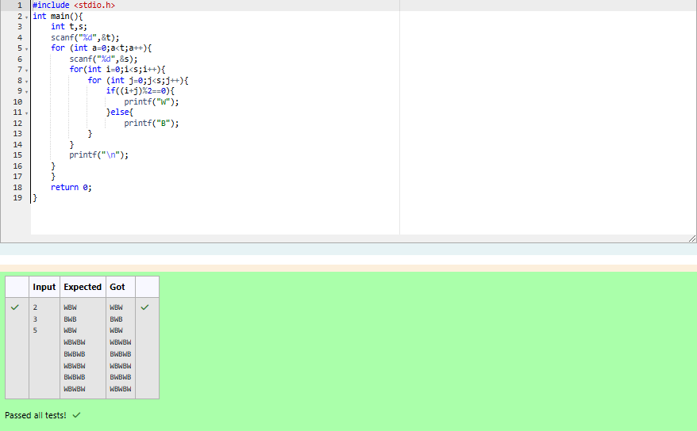

Q) Let’s print a chessboard!

Write a program that takes input:

The first line contains T, the number of test cases

Each test case contains an integer N and also the starting character of the chessboard

Output Format

Print the chessboard as per the given examples

Sample Input / Output

Input:

2

2 W   
3 B

Output:

WB   
BW   
BWB   
WBW   
BWB

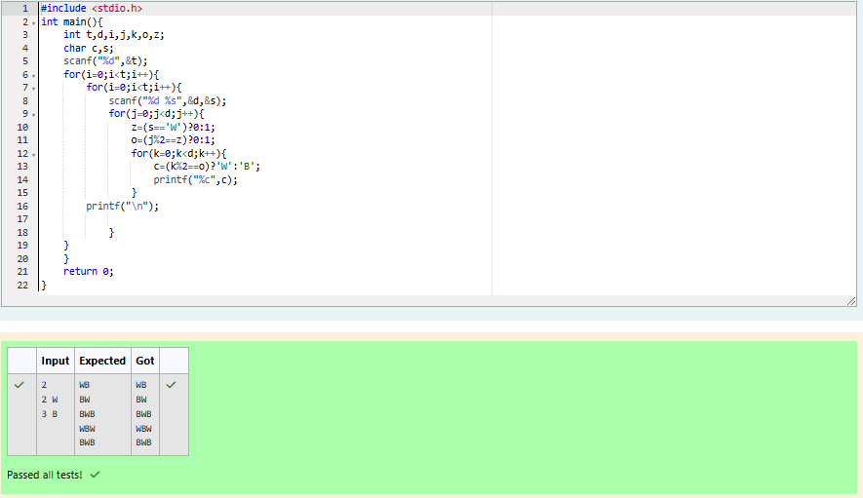

Q) Decode the logic and print the Pattern that corresponds to given input.

If N= 3

then pattern will be :

10203010011012   
\*\*4050809   
\*\*\*\*607

If N= 4, then pattern will be:

1020304017018019020   
\*\*50607014015016   
\*\*\*\*809012013   
\*\*\*\*\*\*10011

Constraints

2 <= N <= 100

Input Format

First line contains T, the number of test cases   
Each test case contains a single integer N   
Output   
First line print Case #i where i is the test case number In the subsequent line, print the pattern

Test Case 1

3   
3   
4   
5   
Output  
 Case #1   
10203010011012   
\*\*4050809   
\*\*\*\*607   
Case #2   
1020304017018019020   
\*\*50607014015016   
\*\*\*\*809012013   
\*\*\*\*\*\*10011   
Case #3   
102030405026027028029030   
\*\*6070809022023024025   
\*\*\*\*10011012019020021   
\*\*\*\*\*\*13014017018   
\*\*\*\*\*\*\*\*15016

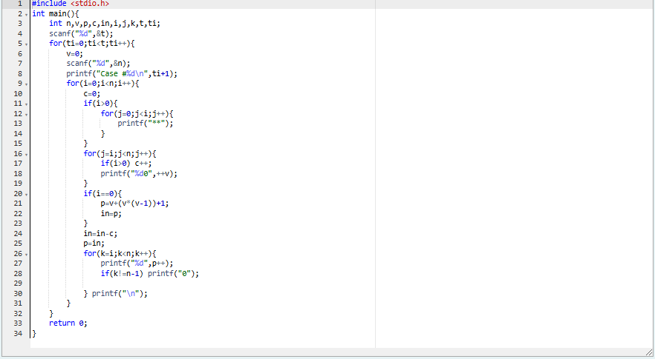

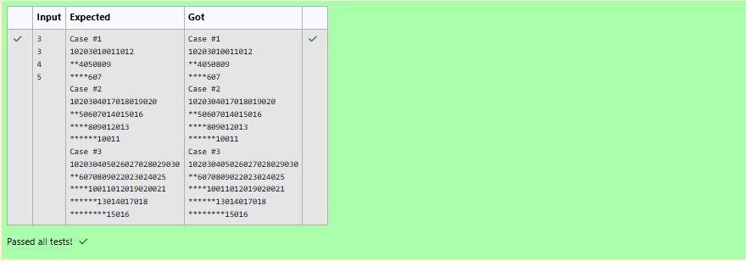

Q) The k-digit number N is an Armstrong number if and only if the k-th power of each digit

sums to N.

Given a positive integer N, return true if and only if it is an Armstrong number.

Example 1:

Input:

153

Output:

true

Explanation:

153 is a 3-digit number, and 153 = 1^3 + 5^3 + 3^3.

Example 2:

Input:

123

Output:

false

Explanation:

123 is a 3-digit number, and 123 != 1^3 + 2^3 + 3^3 = 36.

Example 3:   
Input:   
1634   
Output:   
true   
Note:   
1 <= N <= 10^8

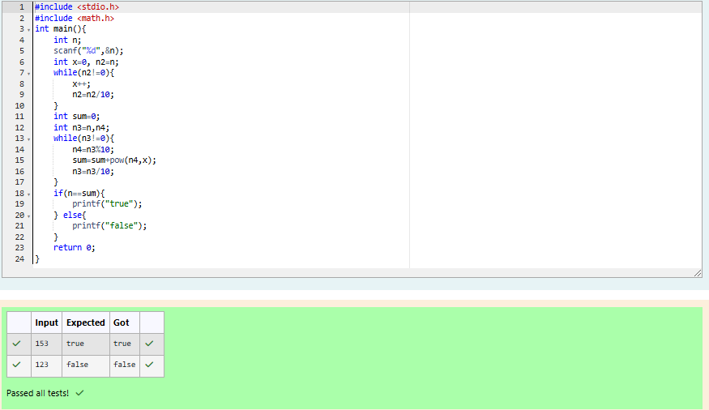



Q) Take a number, reverse it and add it to the original number until the obtained number is a palindrome. Constraints 1<=num<=99999999 Sample Input 1 32 Sample Output1 55

Sample Input 2 789 Sample Output 2 66066

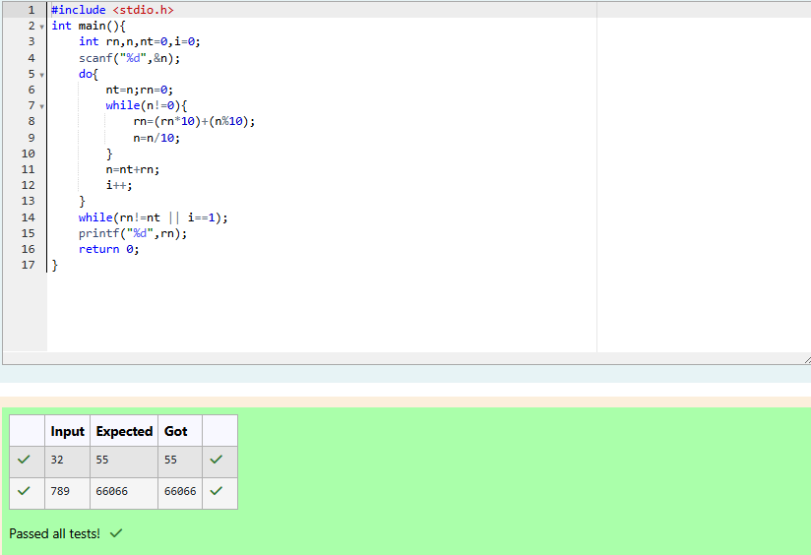

Q) A number is considered lucky if it contains either 3 or 4 or 3 and 4 both

in it. Write a program to print the nth lucky number. Example, 1st lucky

number is 3, and 2nd lucky number is 4 and 3rd lucky number is 33 and 4th

lucky number is 34 and so on. Note that 13, 40 etc., are not lucky as they

have other numbers in it.

The program should accept a number 'n' as input and display the nth lucky

number as output.

Sample Input 1:

3

Sample Output 1:

33

Explanation:

Here the lucky numbers are 3, 4, 33, 34., and the 3rd lucky number is 33.

Sample Input 2:

34

Sample Output 2:

33344



